**Battle of the century**

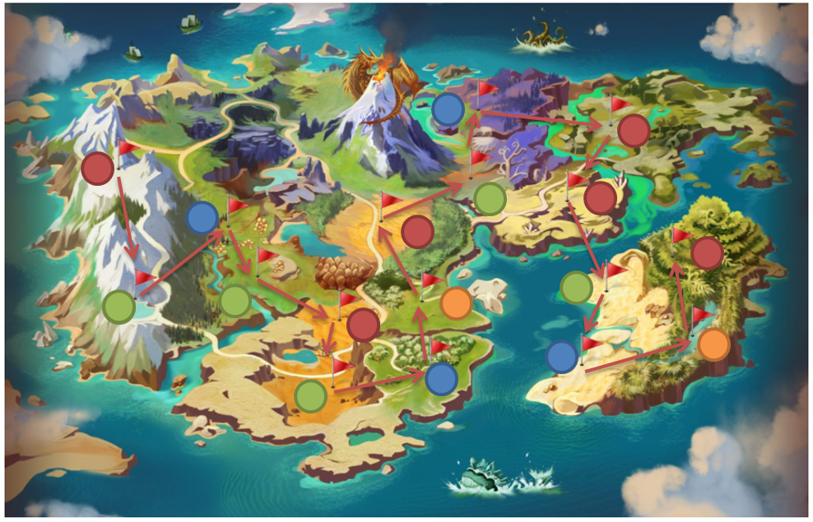

**Game premise:**

Conquering all positions on the map or capturing as many important positions on the map will be the winner. Note the strategies that the opponent is contemplating to choose the appropriate defense including changing the appropriate types of troops.

On the game map there are 4 colored dots representing important areas that players need to pay attention to:

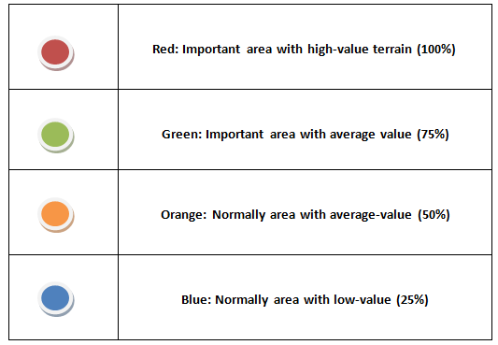

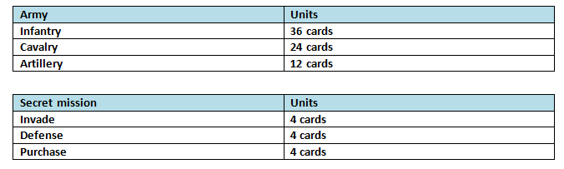**There are a total of 84 paper cards:**

**The power of the cards:**

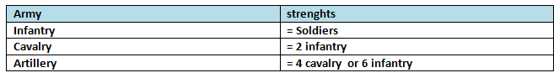

At any time, you can upgrade your minions if you have enough cards in hand.

Rules and game mechanics:

1. First, each player will receive 9 infantry cards and roll the dice who has the highest score will take precedence and assert ownership in the desired position (the card must be face down face). The next round starts from the left side of the first player in each round. Everyone wears all rings when there are no cards left (there is no limit to the number of cards per slot a player has claimed).

2. After shuffling 12 secret mission cards and each person draws 3 cards and place them face down on the map in 3 desired positions.

3. Next to roll the dice the highest score will be able to decide to upgrade troops, defeat the opponent's army or defend.

4. Only conquer trade-in neighboring territories, and not jump out of position.

Strategy:

At each turn, the player will calculate how many soldiers it takes to add to the critical position and needs to control it. If there is a secret quest there must be on the quest first and must face the card up when performing the quest.

Invade:

If your position has a quest card (must be a priority) or you plan to invade, when attacking you must have a larger number of cards or a larger conversion value to capture (must face up at your position and your opponent's up to compare). If you have few or equal troops you will lose your position that is occupied.

Defense:

You can use a roll of your dice to reinforce troops if the position you occupy is important.

Purchase:

If you have a quest card to trade for occupation value, you must agree with another player about the occupied value = the number of troops you have to convert.

End:

The player must destroy their opponent to occupy all positions on the map or occupy 5 red positions on the map will be the winner.

The testing of the game forced me to present practical situations that would happen to create perfect game rules and fewer errors. After thinking of strategies and direction when forming a rule of the game, the last thing is to do later to make up their logic. Besides, the implementation of the plans proposed by the group is a difficult problem when implementing the ideas that form the common ideas of the group. How to give out all of your ideas and persuade other members of the group? However, it is not easy when the new members know each other and do not understand each other's personalities, so conflicts will be inevitable. It is important to control emotions and overcome feelings of guilt when working with group tasks. Through these sessions, it is necessary to have practical exchange time instead of just meeting over the internet because it will be difficult to give opinions and implement ideas of individuals and team members.

The list of team members includes Will connel, Connor winspur, Hou Yuen Yap.

**References:**

Thegioiboardgame (2016) *HƯỚNG DẪN CHƠI BOARD GAME RISK*. Available from: http://thegioiboardgame.vn/blogs/board-game-mo-rong/huong-dan-choi-game-risk [Accessed 10 November 2020].